Supplementary materials:
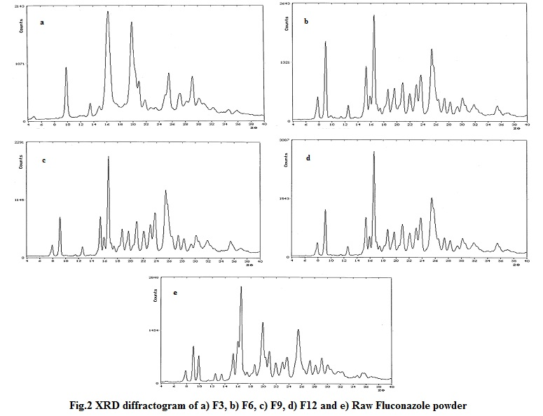
Figure S1. XRD diffractograms of (a) F3, (b) F6, (c) F9, (d) F12 and (e) Raw Fluconazole powder.

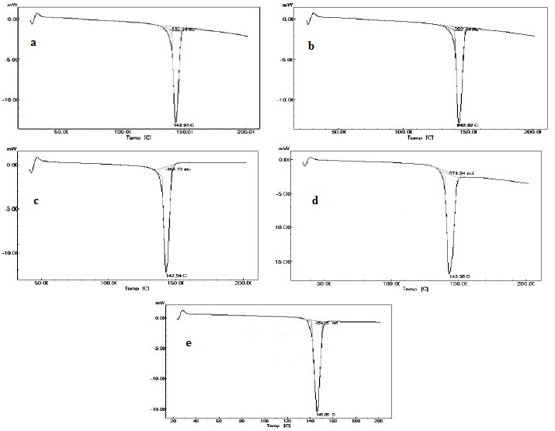
Figure S2. DSC thermograms of (a) F3, (b) F6, (c) F9, (d) F12 and e) Raw Fluconazole powder.

