Figure S1. A) Effect of the concentration of HPMC polymer on the encapsulation efficiency (●) and the drug loading (■ ), B) effect of particle size on the encapsulation efficiency (● ) and drug loading(■ ).

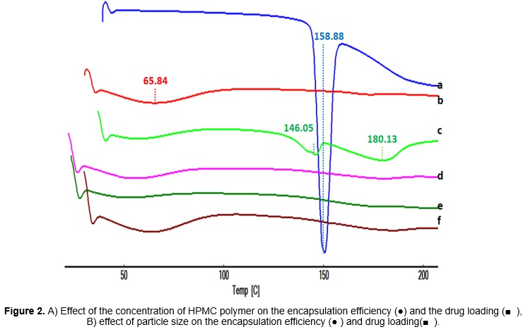
Figure S2. DSC thermogram of selegiline (a), HPMC (b), physical mixture F1 (c), F1 (d), F2 (e) and F3 (f).

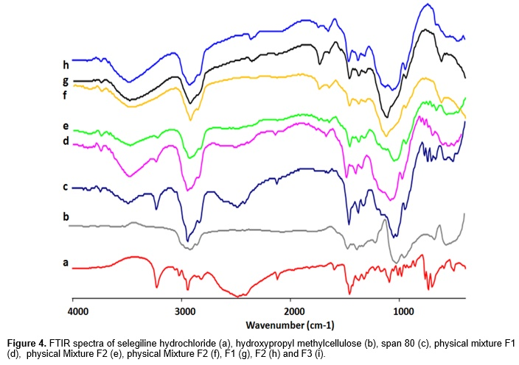
Figure S3. FTIR spectra of selegiline hydrochloride (a), hydroxypropylmethyl cellulose (b), span 80 (c), physical mixture F1 (d), physical Mixture F2 (e), physical Mixture F3 (f), F1 (g), F2 (h) and F3 (i).

